Installation Guide for EditX
For XML labs we will use EditX XML editor.
Trial version is available for one month, that will be sufficient for this module.
Download EditX from the following URL:
https://www.editix.com/download.html
Scroll down to read instruction carefully, based on your OS type.
Select version based on your OS:
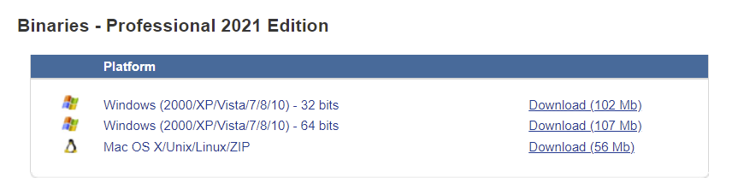

Installing on Windows

Download executable based on type of your OS.
Right click exe and run as administrator.

Upon running following interface should be shown:

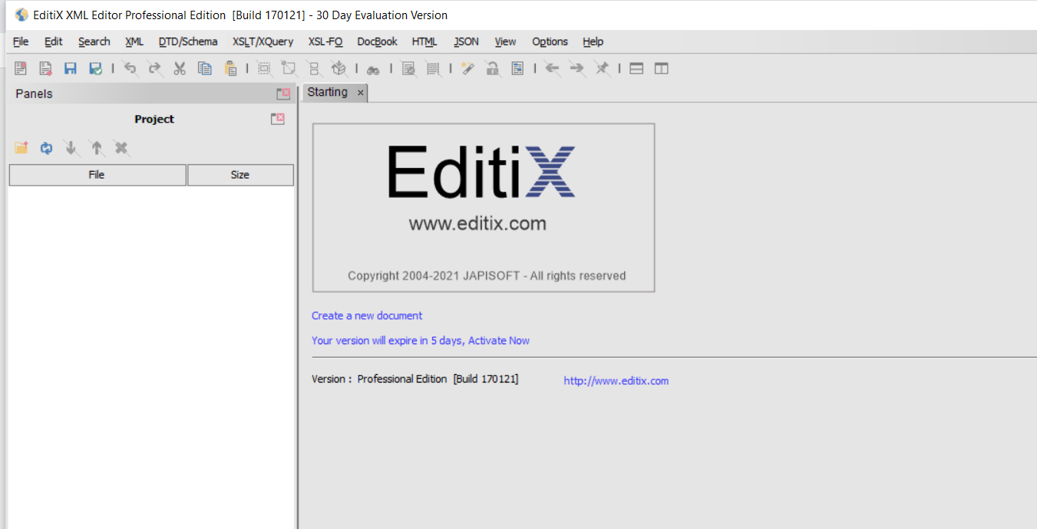

Installing the ZIP version for Mac OS X

1. Get from the download page the latest ZIP version

2. Unzip the file. We suppose for this example, this document is located inside the Downloads/editix2021 directory from your Home directory. You can put it anywhere !

3. Open a terminal and use the following commands for changing the attribute of the file editix.sh to be executed. We use here ~/Downloads/editix2021 for the folder as an example, you can choose another name.

cd ~/Downloads/editix2021/bin
chmod u+x editix.sh
“chmod u+x file means add the executable bit to the owner of the file while ignoring the umask (Your mod will be set, no question).

Once this operation is done, you can execute editix using editix.sh inside the bin directory. You may also run it from the terminal with "./editix.sh".

You can run it after as any mac os x applications, you don't have to use the terminal for running it.

Editix is now started. Congratulation !

NOTE: you need Java Run time environment to install EditX.
Check java version using following command inside your console(terminal)

java -version

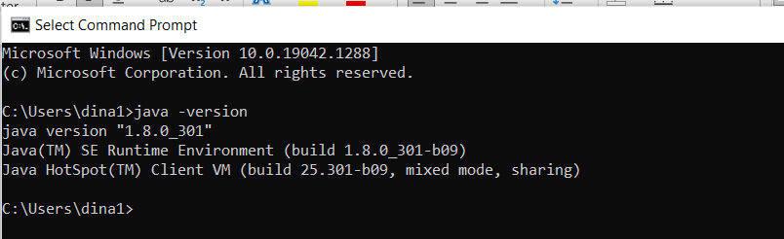

Note : if JRE does not found, install it using the below link https://java.com/en/download/apple.jsp

The interface looks like this in Mac:

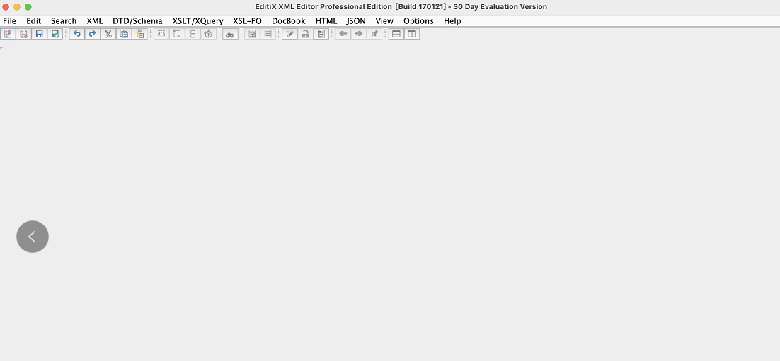

key:
2153384436504026269559258574569087156444845740868687832176289575931801538732495383150841882401282026904670457214278598751963798856276436545427884529489979

